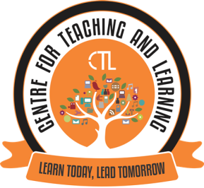
JUNE-2020 (Monthly Report-CTL)
The Centre for Teaching Learning (CTL) powered by IQACconductedExpert FDP Webinar Series on Effective Online Teaching, Learning and Evaluation on 23rd and 24th June, 2020 for the faculty of our College. Dr.SameenaFalleiro, Co-ordinator of CTL Chowgule College was the Convenor of the FDP. She highlighted the Role of CTL in these COVID times and shared with the participants that the Expert Webinar Series is a continuous FDP wherein the CTL provides a platform and invites eminent Experts in the area of ICT and Education to share their expertise with the faculty. The CTL also plans to organise regular in-house training and interactive sessions for the college faculty.
Dr. Vini Sebastian, Associate Professor, St. Xavier’s Institute of Education, Mumbai was the Resource person for this FDP. The topics covered were E-content and OER, Online Transaction – The New Normal, Blended Learning – Boosting Student Engagement, Teaching Methodologies and E-assessment.Around 60 Faculty from our college participated in this event.
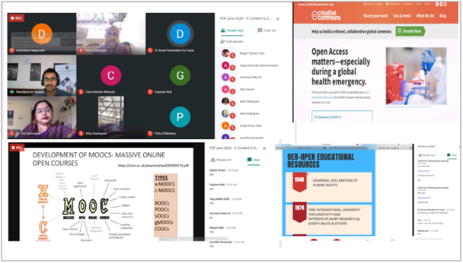
Screenshots of the FDP webinar in progress via Google Meet
1. Mr. Andrew Barreto, Assistant Professor and Co-Coordinator of CTL, conducted a session on E-portfolio on 25th June, 2020 for the faculty of our college. Around 10 Faculty from our college participated in this event.
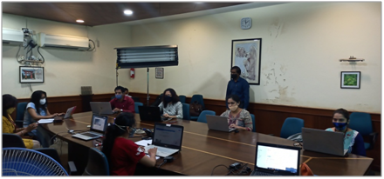
E-portfolio session in progress

